**LAB ASSIGNMENT 3**

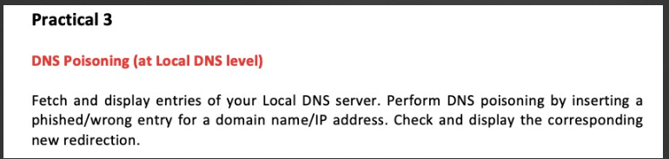

**REDIRECTING** [**WWW.PUNJABIUNIVERSITY.AC.IN**](http://WWW.PUNJABIUNIVERSITY.AC.IN) **TO THAPAR.EDU**

Finding the IPADDRESS of the website TO which we want to redirect:

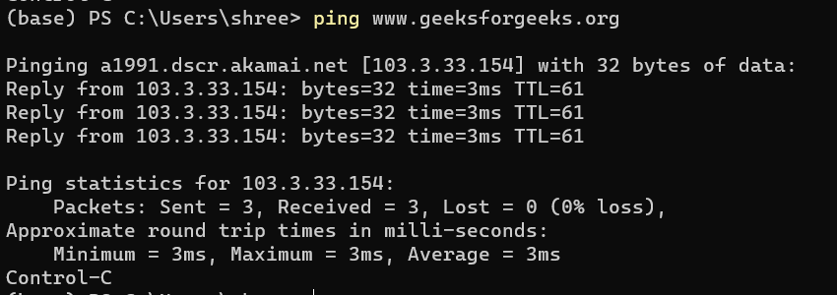

Going to the hosts file with administrator access:



Change in the hosts file



**Looking at the website in action:**



**REDIRECTING THAPAR.EDU TO YOUTUBE.COM**